C183 Week 6 Lab
Projection
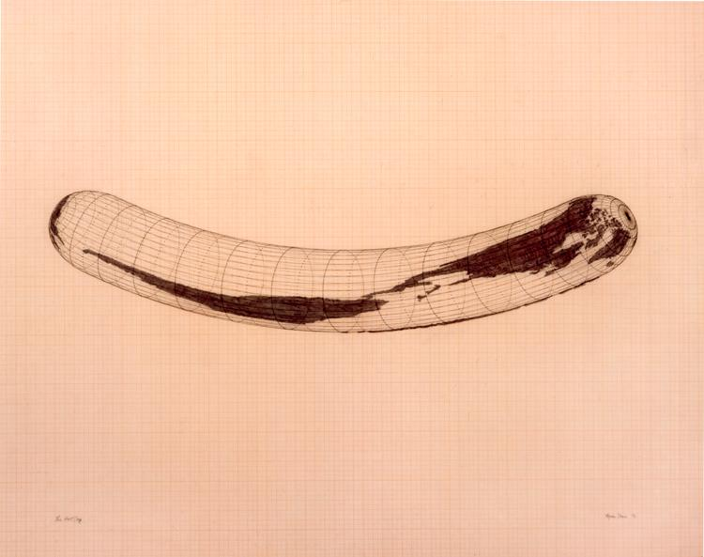

Agnes Denes, 1978, Isometric Systems in Isotropic Space-Map Projections: The Cube

Assessment Due Date:
- September 30th, 11:59 PM
- Upload this as a PDF with the reflection responses filled out, and a screenshot of each projection from the exploratory prompts.
Assessment Criteria:
- Completion of Foundational walk-through
- Completion of Exploratory prompts (select 2)
- Completion of Reflection on practice
Foundational Walk-through:
- Access the Scribe Pro documentation on the course website, and proceed with following the steps.
- At the end of the walk-through, include a screenshot of the final projection below:

Exploratory Prompts:

Select 2, Pursue a 3rd if time permits
Curated data for each prompt can be found in this week’s lab page in the bCourses “Files” section.

- State Scale
  - You are a political science researcher for the Public Policy Institute of California, and it is election season. Your team needs to make a map showing the state-wide results for the recent primary results.
- Regional Scale
  - You are a graphics journalist for Le Monde Magazine. The evening edition is reporting on the state of the Arctic, and wants to show a map of the regional territorial dispute over Arctic EEZs and shipping lanes.
- World/Global Scale
  - You spend time with some friends down at Middle Harbor Shoreline Park, witnessing the huge container ships pulling into Port of Oakland. It becomes a personal project to learn more about the impact of maritime container shipping on cities. An exploration into this topic requires making a map of port cities around the world and the amount of containers they receive per year.

Below, include A) a screenshot of the projection constructed in ArcPro and B) A sketch of how the Earth is being distorted in the projection (please label with a text box the corresponding prompt):

Reflection:

What perspectives are you seeing these worlds through? How is the Coordinate Reference System (GCS/PCS/Projection) you chose structured? What aspects of Earth does the projection emphasize over others?

Using a quote from the weekly reading, entangle the technical work you performed with the larger intellectual issues in cartography:

